**DIPLOMA IN INFORMATION TECHNOLOGY**

**PROJECT TITLE: DEVELOPMENT OF A PHARMACY MANAGEMENT SYSTEM**

**FUNDI EWEN NGONDI**

**SCT121-0700/2023**

**SAMUEL BAYA KITSAO**

**SCT121-0625/2023**

*A proposal submitted to the Department of information technology in the School of computing and informatics in partial fulfillment of the requirements for the award of Diploma in Information Technology Jomo Kenyatta University of Agriculture and Technology.*

*2025*

*This proposal is my original work and has not been presented for a degree in any other University*

*Signature.........................................Date............................................................*

This proposal has been submitted for examination with my approval as University Supervisor

Signature.......................................................... Date....................................................

**TABLE OF CONTENTS**

Introduction……………………………………………………………………………………………………………………….3

Problem definition…………………………………………………………………………………………………………………………..4

Proposed solution……………………………………………………………………………………………………………………………4

Objectives………………………………………………………………………………………………………………………………………..5

Justification……………………………………………………………………………………………………………………………………..5

Methodology…………………………………………………………………………………………………………………………………..5

Resources……………………………………………………………………………………………………………………………………….7

Budget……………………………………………………………………………………………………………………………………………8

Project schedule…………………………………………………………………………………………………………………………….9

Gantt chart……………………………………………………………………………………………………………………………………..10

**INTRODUCTION**

Ultracare Pharmacy is a growing, mid-sized retail pharmacy located in the heart of Juja’s commercial district, serving a wide range of customers including students, working professionals, families, and senior citizens. Known for its accessibility and reliable customer service, Ultracare specializes in dispensing both prescription and over-the-counter (OTC) medicines, health supplements, personal care products, and basic medical supplies. The pharmacy plays a vital role in supporting the community’s healthcare needs and is frequented by clients from nearby clinics, learning institutions, and residential estates.

Despite its critical role in healthcare delivery, Ultracare Pharmacy currently operates with predominantly **manual systems**, which impact both efficiency and accuracy. The pharmacy opens daily at 7:30 AM. The pharmacist and two assistants begin the day by cleaning the counters and shelves, organizing medications by therapeutic class, and preparing the cash float for daily transactions. A handwritten sales and stock ledger is placed at the main counter alongside a prescription pad for manually recording drug dispensation.

Throughout the day (8:00 AM – 8:00 PM), walk-in customers bring prescriptions which are verified and filled manually. The pharmacist or assistant identifies medications by scanning shelf labels from memory, checks expiry dates visually, and records each sale in a sales notebook. Over-the-counter customers inquire about common medications, supplements, or health items, and the staff responds based on experience or by checking product information leaflets.

All payments are made in cash, M-Pesa, or bank transfer. A calculator is used to tally the totals, and customers are issued **manual handwritten receipts**. For prescription drugs, a copy of the prescription is stapled to the receipt and stored for compliance. In the case of bulk purchases—such as supply requests from nearby clinics, dispensaries, or health institutions—the order is logged into a “Medical Supply Requests” ledger. These orders are processed manually, and payments are typically made via cheque or bank transfer after an invoice is prepared using printed forms.

When new stock is delivered by pharmaceutical suppliers, the delivery notes are manually cross-checked with purchase orders. The pharmacist or procurement assistant verifies the drug names, quantities, batch numbers, and expiry dates. Upon verification, stock entries are updated in the manual stock register, and items are either shelved or stored in the temperature-controlled backroom.

At the end of the day, the cashier and pharmacist reconcile the sales ledger with cash in the drawer, verify prescriptions dispensed, and record a summary in the daily operations logbook. Expiring medicines, damaged stock, or customer complaints are also logged manually for future action.

**PROBLEM DEFINITION**

**Ultracare Pharmacy’s operations are heavily reliant on manual procedures, which introduce significant inefficiencies and risks across its daily workflow.** Each morning, staff prepare handwritten sales and inventory ledgers, arrange medication shelves, and set up the cash float for the day. Customer prescriptions are verified and recorded manually, while over-the-counter sales are tracked using notebooks and calculator-based transactions. This dependence on physical recordkeeping is not only time-consuming but also vulnerable to human errors such as inaccurate dosage entries, forgotten stock updates, or misplaced prescriptions. Throughout the day, pharmacy staff locate medications by memory or visual identification, check expiry dates by hand, and update stock levels manually after each transaction. Without a centralized inventory or prescription management system, this process results in delays, especially during peak hours or when handling complex medication orders.

Payment handling also remains fully manual. Staff use calculators to total bills, issue handwritten receipts, and record each transaction in physical ledgers. This method often leads to arithmetic errors, loss of receipts, and difficulties during end-of-day cash reconciliation, particularly when dealing with numerous transactions or multiple payment methods (cash, M-Pesa, bank transfers). For health institutions and clinics placing bulk or recurring orders, requests are logged in separate ledgers and coordinated by phone or email, with no integrated system for tracking order progress, stock fulfillment, or delivery schedules. This fragmented approach increases the chances of order duplication, delivery delays, and discrepancies in supplied quantities.

Inventory management at Ultracare is equally constrained. Stock entries, expiry monitoring, and reorder alerts are maintained manually, making it difficult to track real-time stock levels, avoid overstocking or stockouts, or identify expiring medicines in time. These challenges are further complicated by staff-dependent tasks: functions like procurement, prescription verification, or bulk order processing are limited to a few senior personnel, which causes workflow delays when they are unavailable or overwhelmed. At the close of business, the pharmacist and cashier must manually reconcile the day’s cash with sales records, verify dispensed prescriptions, and review inventory changes — a process that is both labor-intensive and prone to oversight. These operational bottlenecks significantly affect Ultracare Pharmacy’s ability to deliver fast, safe, and reliable pharmaceutical services and leave it at a disadvantage compared to modern pharmacies using automated systems for accuracy, compliance, and efficiency

**PROPOSED SOLUTION**

To address the operational challenges facing Ultracare Pharmacy, we propose to design, develop, and implement a **customized Pharmacy Management System** that will automate critical workflows and enhance overall service delivery for both the physical and digital fronts. This solution will not only digitize the pharmacy’s internal operations but also introduce an **online pharmacy platform**, enabling customers to conveniently access medications and health products remotely.

For the physical store, we will build a **centralized digital system** to replace manual prescription logs, sales ledgers, and stock registers, allowing staff to manage prescriptions, track inventory, and process transactions more efficiently and accurately. A **prescription management module** will be developed to securely record, verify, and archive prescriptions digitally, improving traceability and regulatory compliance. To streamline payments, we will integrate a **Point-of-Sale (POS) system** that calculates totals, generates digital receipts, and supports various payment options including cash, M-Pesa, and bank transfers.

An advanced **inventory management module** will provide real-time updates of stock levels after every sale or delivery, and include features such as batch tracking, expiry alerts, and automatic restocking notifications. A **procurement module** will handle purchase orders, supplier tracking, and delivery verification, while a **bulk order management module** will allow staff to capture large orders, auto-generate invoices, and monitor payment statuses, particularly for clinics and institutions. To ensure accountability and security, we will implement **role-based access controls**, assigning different permissions based on staff roles.

In addition to automating the physical store, we propose to develop a **complementary online pharmacy platform**. This platform will allow customers to browse available medications, upload prescriptions, place orders, and choose delivery or in-store pickup options. It will include features such as real-time product availability, secure checkout via mobile money and bank transfers, and automated order tracking. This digital presence will improve accessibility for customers—especially those with mobility challenges or residing farther from the store—and expand Ultracare’s reach within and beyond Juja.

Lastly, we will integrate **automated reporting tools** to generate daily sales reports, reconcile cash and digital payments, and monitor stock movements, significantly reducing the administrative burden on staff. Overall, this end-to-end solution will modernize Ultracare Pharmacy’s operations, boost efficiency and compliance, and provide a professional and convenient experience for both in-person and online customers.

**OBJECTIVES**

1. To design a Pharmacy Management System
2. To test and evaluate the system for functionality
3. To deploy the system and provide documentation

### ****JUSTIFICATION****

This project is being undertaken to address the significant operational challenges currently faced by Ultracare Pharmacy, which relies on manual systems to manage prescriptions, sales, inventory, and supplier coordination. These traditional methods are time-consuming, error-prone, and increasingly unsustainable as customer demand and stock complexity grow. The lack of real-time tracking, digital recordkeeping, and automation poses risks to accuracy, compliance, and overall service quality.

By developing an automated **Pharmacy Management System** with both physical store automation and an online pharmacy platform the project aims to streamline daily operations, improve inventory control, ensure secure and accurate prescription handling, and enhance customer service. The system will reduce workload for staff, support better decision-making through real-time data for management, and provide customers with faster, safer, and more convenient access to pharmaceutical services.

Ultimately, this solution will replace the inefficient manual processes with a secure, scalable, and user-friendly digital platform, directly addressing the client’s needs while contributing to the digital transformation of pharmacy operations in the healthcare sector.

## ****METHODOLOGY****

This project will adopt the **Agile methodology**, which emphasizes iterative development, adaptability, and collaboration. The system will be built in short sprints, with each sprint delivering functional components that are tested and refined before progressing.

The two team members will begin by jointly gathering requirements through site visits, interviews, and questionnaires with Ultracare Pharmacy staff. They will then collaborate to **finalize the database design**, which will form the foundation of the system.

Once the database is complete, tasks will be divided:

**Member 1:** Backend development – server-side logic, database connectivity, business rules, and APIs.

**Member 2:** Frontend development – user interfaces for the POS system, dashboards, online pharmacy platform, and integration with backend APIs.

Regular check-ins will be held to track progress and resolve issues. At the end of each sprint, **Sprint Reviews** will be conducted to demonstrate completed features and collect feedback.

In the final phase, the system will be fully integrated and tested (functional, integration, and UAT). After deployment, the team will provide training, user manuals, and post-deployment support to ensure smooth operation.

### RESOURCES

### This project requires a combination of human, software, and physical resources to ensure successful design, development, testing, and deployment of the Bookshop Management System.

### **Human Resources**

* Project Developers (2): Responsible for gathering requirements, designing, developing, testing, and deploying the system. They will also provide user training and prepare system documentation.
* Supervisor: Provides academic and technical guidance, monitors project progress, and ensures adherence to academic standards.

Software Resources

**Software Tool Specification/Purpose**

1 Visual Studio Code Integrated Development Environment (IDE) for writing editing

code.

2. XAMPP Local server environment for hosting and testing the application.

MySQL Database management system for storing and retrieving data.

3 PHP Backend programming language for implementing server-side

logic.

4. HTML, CSS, Jaavscript Frontend technologies for designing user interfaces.

**Physical Resources**

**Item** **Item**

1.Laptop Minimum specifications: Intel Core i5 processor, 4GB RAM, 256GB

HDD, for system development and testing.

2. Flash Drive 16GB capacity for backing up project files and transferring data between

devices.

3. Internet Access Required for downloading libraries, software tools, and conducting research

during the development process.

### **Financial Resources**

A small budget will be required for internet access, printing documentation, and other incidental expenses.

##### **BUDGET**

|  |  |  |  |  |
| --- | --- | --- | --- | --- |
| **I**TEM | SPECIFICATION | QUANTITY | UNIT COST(KSH) | TOTAL COST(KSH) |
| Laptop | Intel Core i5, 4GB RAM, 256GB HDD (for development) | 1 | Available | 0 |
| Internet Access | For downloading libraries, tools, research (monthly) | 1 month | 1000 | 1000 |
| Flash Drive | |  | | --- | |  |  |  | | --- | | 16GB, for backups and file transfer | | 1 | 1200 | 1200 |
| XAMPP (free software) | Local server for hosting and testing | - | free | 0 |
| Visual Studio Code (free) | Code editor for writing and editing code | - | free | 0 |
| PHP/HTML/CSS/JS (free) | For frontend and backend development | - | free | 0 |
| Printing & Documentation | Printing user manuals and reports for submission | 30 pages | 10 | 300 |
| Total Estimated Cost |  |  |  | 3700 |

##### **PROJECT SCHEDULE**

|  |  |  |  |  |  |  |  |  |
| --- | --- | --- | --- | --- | --- | --- | --- | --- |
| No. | Activity/Task | Expected Start Date | Expected End Date | Actual Start Date | Actual End Date | Duration  *(hrs)* | Deliverables |  |
| *1* | Project Identification | July 11, 2025 | July 17, 2025 |  |  | *20 hours* | Approved project topic |  |
| *2* | Proposal Writing | July 18, 2025 | July 24, 2025 |  |  | *40 hours* | Completed and approved proposal |  |
| *3* | Data Collection | July 25, 2025 | July 31, 2025 |  |  | *40 hours* | Collected user requirements |  |
| *4* | Data Analysis | August 1, 2025 | August 7, 2025 |  |  | *30 hours* | Refined system requirements |  |
| *5* | |  | | --- | |  |  |  | | --- | | System Design | | August 8, 2025 | August 14, 2025 |  |  | *50 hours* | System design documents & wireframes |  |
| *6* | System Development | August 15, 2025 | August 28, 2025 |  |  | *60 hours* | Developed and functional system |  |
| *7* | |  | | --- | |  |  |  | | --- | | Testing | | |  | | --- | |  |  |  | | --- | | August 29, 2025 | | September 4, 2025 |  |  | *30 hours* | Tested and bug-free system |  |
| *8* | |  | | --- | |  |  |  | | --- | | Deployment | | September 5, 2025 | September 11, 2025 |  |  | *20 hours* | Fully deployed and operational system |  |

###### 

###### **GANTT CHART**

|  |  |  |  |  |  |  |
| --- | --- | --- | --- | --- | --- | --- |
| Activities | Duration(days) | 20 | 30 | 40 | 50 | 60 |
| Project Identification | 7 days |  |  |  |  |  |
| Proposal Writing | 7 days |  |  |  |  |  |
| Data Collection | 7 days |  |  |  |  |  |
| Data Analysis | 7 days |  |  |  |  |  |
| System Design | 7 days |  |  |  |  |  |
| System Development | 7 days |  |  |  |  |  |
| |  | | --- | | Testing | | 7 days |  |  |  |  |  |
| |  | | --- | | Deployment | | 7 days |  |  |  |  |  |

## ****CHAPTER TWO****

### ****DESCRIPTION OF THE PROBLEM DOMAIN****

Pharmacies are key to healthcare delivery, but many, like Ultracare Pharmacy, still depend on manual processes to manage prescriptions, sales, and inventory. Staff record transactions and stock updates in handwritten ledgers, which is time-consuming and prone to errors such as incorrect dosage entries, misplaced records, and delayed stock updates. This often leads to inefficiencies like stockouts, unnoticed expired drugs, and slow customer service.Payment handling is also manual, relying on calculators and handwritten receipts, making daily cash reconciliation difficult. Bulk orders from clinics and institutions are recorded separately, leading to delays, duplication, and challenges in tracking order status. Overall, these outdated methods affect accuracy, customer satisfaction, and the pharmacy’s ability to compete with automated pharmacies.A computerized Pharmacy Management System is needed to centralize operations such as prescription handling, inventory control, sales processing, and reporting. This will reduce human errors, provide real-time updates on stock levels, send expiry alerts, and speed up service. For Ultracare Pharmacy, adopting an automated system is essential for efficiency, accuracy, and better customer service.

### ****TARGET POPULATION****

The primary target population for the Pharmacy Management System comprises the staff of Ultracare Pharmacy, including pharmacists, pharmacy assistants, cashiers, and procurement personnel. Pharmacists and assistants will use the system to handle prescriptions, manage sales, and update inventory in real-time, while cashiers will use the integrated Point-of-Sale (POS) module to process payments and generate receipts. Procurement staff will rely on the system for supplier management, purchase orders, and monitoring stock levels and expiry dates.Secondary users include customers—both walk-in and online—who will benefit from faster, more accurate service and easy access to products, as well as pharmaceutical suppliers who will interact indirectly when fulfilling digital purchase orders. This target population was selected because the system is designed to streamline pharmacy operations at all levels, improving efficiency for staff while enhancing service quality for customers and suppliers.

### ****DATA COLLECTION****

### ****Analysis of collected data****

To understand the operational challenges faced by Ultracare Pharmacy, data was collected using four primary methods: **interviews, observations, questionnaires, and document review**.

* **Interviews:** One-on-one discussions were conducted with the pharmacist, pharmacy assistants, cashiers, and procurement staff to gather detailed insights into daily workflows and challenges.
* **Observations:** Direct observation of pharmacy operations was carried out at different times of the day to capture how prescriptions, sales, and inventory processes were handled in real-time.
* **Questionnaires:** Structured questionnaires were distributed to both staff and customers to obtain broad feedback regarding service efficiency, accuracy, and overall satisfaction.
* **Document Review:** Existing sales ledgers, inventory records, and prescription logs were examined to identify inconsistencies, inefficiencies, and risks associated with manual record-keeping.

**Findings**

After analyzing the collected data, we identified the following key points:

**1. Frequent Errors in Manual Prescription and Inventory Updates**

Because all records are written by hand, there is a high chance of human error when entering prescription details or updating inventory levels. For example, incorrect dosage entries or forgetting to record sold items can occur. These errors compromise patient safety and make it difficult to maintain accurate stock levels.

**2. Long Customer Wait Times**

Customers often have to wait longer, especially during busy hours, because staff must search for medicines manually and calculate prices using calculators. This slow process frustrates customers and reduces the pharmacy’s ability to serve more people efficiently.

**3. Lack of Real-Time Inventory Tracking**

Stock updates are only done at the end of the day in the manual system. This means the pharmacy staff may unknowingly sell out-of-stock medicines or fail to reorder in time. As a result, stockouts and expired medicines on shelves become more common.

**4. Difficulties in Bulk Order Management**

Bulk orders from clinics and institutions are recorded separately from daily sales. This leads to duplicated entries or missing information, making it hard to track which orders have been delivered or paid for. It also causes delays in fulfilling these large orders.

### ****REVIEW OF EXISTING AND SIMILAR SYSTEMS****

**a) Pharmcare by Futuresoft Technologies (Kenya)**

Tailored for retail pharmacies to manage pharmaceutical and non-pharmaceutical stocks, track expiry dates, and automate reorder alerts.

**Features:** Batch traceability, first-expiry-first-out handling, accounting modules, automatic backup, and user access control.

**b) JiPharm Pharmacy Software (Richcom Solutions, Kenya)**

Cloud-based and desktop versions, integrated with Lipa Na M-Pesa for mobile payments.

**Core modules:** Drug management and issuance, supplier/customer management, auto invoicing, auto VAT calculation, barcode scanner/POS, promotions, and HR modules.

**Features offered by existing systems:**

**Pharmcare:** Real-time inventory tracking, expiry alerts, reorder automation, and integrated accounting and reporting modules.

**JiPharm:** End-to-end operations including drug issuance, barcode-based POS, mobile payments, auto pricing and VAT, customer promotions, and multi-user access control.

**Drawbacks and limitations:**

**Pharmcare:** Desktop-based model may not easily support remote access or online ordering. Bulk order tracking and customer-facing interfaces are not well supported.

**JiPharm:** Licensing and subscription costs can be high for small pharmacies, and the broad HR modules may be unnecessary.

**How the proposed Ultracare PMS improves on these solutions:**

**Local Customization:** Specifically designed to handle Ultracare’s workflows, including bulk order tracking and local payment methods (M-Pesa).

**Integrated Modules:** Combines prescription handling, inventory, supplier management, POS, and online ordering into one platform, ensuring seamless data flow.

### ****FEASIBILITY STUDY****

1. **Technical Feasibility**

The study commenced with an assessment of the technical requirements and resources needed for the development of the system. The evaluation revealed that the project successfully utilized open-source technologies such as PHP, JavaScript, and MySQL, which aligned well with the development tools available, including Visual Studio Code. The development team already had sufficient expertise to manage full-stack development, and the project did not require any specialized hardware or proprietary software. This established that the system was technically achievable with the resources that were accessible.

1. **Economic Feasibility**

The financial assessment showed that the Pharmacy Management System required only a small monetary investment. Since the development was carried out using free and open-source tools and platforms, most of the costs were related to time and effort rather than direct financial expenditure. Furthermore, the long-term benefits—such as increased operational efficiency, reduced paperwork, better inventory control, and improved coordination with suppliers—far outweighed the minimal initial setup costs. This confirmed that implementing the system was well justified from a cost-benefit perspective.

1. **Operational Feasibility**

The operational review confirmed that the system was well-suited for day-to-day pharmacy activities. Its user-friendly interface allowed staff to adapt quickly with minimal training, making the transition from manual to automated processes smooth and effective. Because the development team engaged pharmacy staff throughout the design and testing stages, user requirements were fully addressed, which increased acceptance and confidence in the system. Additionally, the system was seamlessly integrated into existing workflows, replacing manual ledgers with automated processes that improved efficiency and reduced errors.

1. **Schedule Feasibility**

The project timeline was carefully planned and successfully adhered to using the Agile methodology. Development was carried out in short, manageable sprints, each producing functional components that were tested and refined before moving forward. The team worked collaboratively at every stage, which ensured that tasks were completed on time without compromising quality. By dividing responsibilities between backend and frontend development and synchronizing progress regularly, the system was completed and deployed within the original timeframe, demonstrating that the project was fully achievable within the set schedule

**e) Legal and Ethical Feasibility**

The evaluation also established that the Pharmacy Management System complied with all relevant legal and ethical standards. Sensitive data such as patient prescriptions and customer information was handled securely through user authentication, role-based access controls, and data encryption. The system maintained strict confidentiality and adhered to data protection guidelines, ensuring that only authorized personnel could access critical information. By incorporating these measures, the system promoted ethical handling of patient data and met all regulatory requirements.

**CHAPTER THREE**

**SYSTEM ANALYSIS AND DESIGN**

**System Analysis**

In this phase, the goal was to gain a clear understanding of Ultracare Pharmacy’s current operations and identify the system requirements that would guide the design and development of a fully functional Pharmacy Management System. The analysis focused on both functional and non-functional requirements, which were gathered through staff feedback, direct observation of daily workflows, and a review of existing records and processes.

**Introduction**

This section provides an analysis of the current processes used in managing pharmacy operations, highlights the limitations of the existing manual system, and outlines the requirements for the proposed Pharmacy Management System. The goal is to understand the functional needs and operational context that the system must address in order to improve efficiency, accuracy, and overall service delivery.

**System Design**

**Requirement Specifications**

### ****1. Functional Requirements****

These define **what the system must do (features and modules):**

1. **User and Role Management**

Allow user registration and login for Admin, Pharmacist, Cashier, Procurement staff, and Customers.

Implement role-based access control so users only access features relevant to their roles.

1. **Prescription Management**

Record, verify, and archive prescriptions digitally.

Maintain prescription history for each customer and ensure regulatory compliance.

1. **Inventory Management**

Track stock levels in real-time after every sale or stock delivery.

Monitor batch numbers and expiry dates with automatic alerts for low stock or soon-to-expire medicines.

Generate automatic restocking notifications.

1. **Sales & Point-of-Sale (POS)**

Process sales and bulk purchases with support for cash, M-Pesa, and bank transfers.

Automatically calculate totals, taxes, and discounts, and generate digital receipts.

Maintain digital records of daily, weekly, and monthly sales.

1. **Supplier & Procurement Management**

Manage supplier information and maintain purchase orders.

Track deliveries and automatically update inventory upon confirmation.

1. **Bulk Order Handling**

Capture large orders from clinics and institutions.

Automatically generate invoices and track order progress until delivery and payment.

1. **Online Pharmacy Platform**

Allow customers to browse products, upload prescriptions, place orders, and choose delivery or pickup options.

Display real-time product availability and enable secure checkout.

1. **Reporting & Analytics**

Generate reports on sales, inventory, expiry dates, and bulk orders.

Provide dashboards for admins and management to view key performance metrics.

### ****Non-Functional Requirements****

These define **how the system should perform (quality attributes):**

1. **Performance**

Transactions and inventory updates must process in real-time with minimal delay.

Support at least 10 concurrent users without affecting performance.

1. **Security**

Enforce secure login with encrypted passwords and user authentication.

Restrict data access based on user roles (e.g., only pharmacists can approve prescriptions).

Encrypt sensitive data (customer, prescription, and payment records) during storage and transmission.

1. **Usability**

Provide a simple, intuitive interface that staff with minimal technical skills can use effectively

The system must be compatible with both desktops and mobile devices (for online customers).

1. **Reliability & Availability**

Ensure 99% uptime during pharmacy operational hours.

The system must handle unexpected failures without losing critical data.

1. **Backup & Recovery**

Perform automatic backups at least once a day.

Allow recovery of data from backups in the event of a system crash or database failure.

1. **Scalability**

The system must be designed to accommodate future expansion, including multiple branches or additional users.

1. **Compliance & Ethics**

After establishing the system requirements, the design phase outlined how the Pharmacy Management System would be structured to meet those needs. The system design was divided into four key parts: Logical Design, Physical Design, Interface Design, and Database Design. Together, these components served as the blueprint for the development phase.

**LOGICAL DESIGN**

The logical design represents the abstract structure of the Pharmacy Management System without focusing on its physical implementation. It involves modeling user interactions, data flow, and system behavior using diagrams such as use case diagrams, class diagrams, package diagrams, object diagrams, and entity-relationship diagrams (ERDs).

This phase defined how different users—pharmacists, cashiers, procurement staff, administrators, and customers—interact with the system, including tasks such as prescription management, sales processing, inventory updates, bulk order handling, and reporting. Relationships between users and data elements were clearly mapped to ensure efficient and accurate system operations.

**Class Diagram**

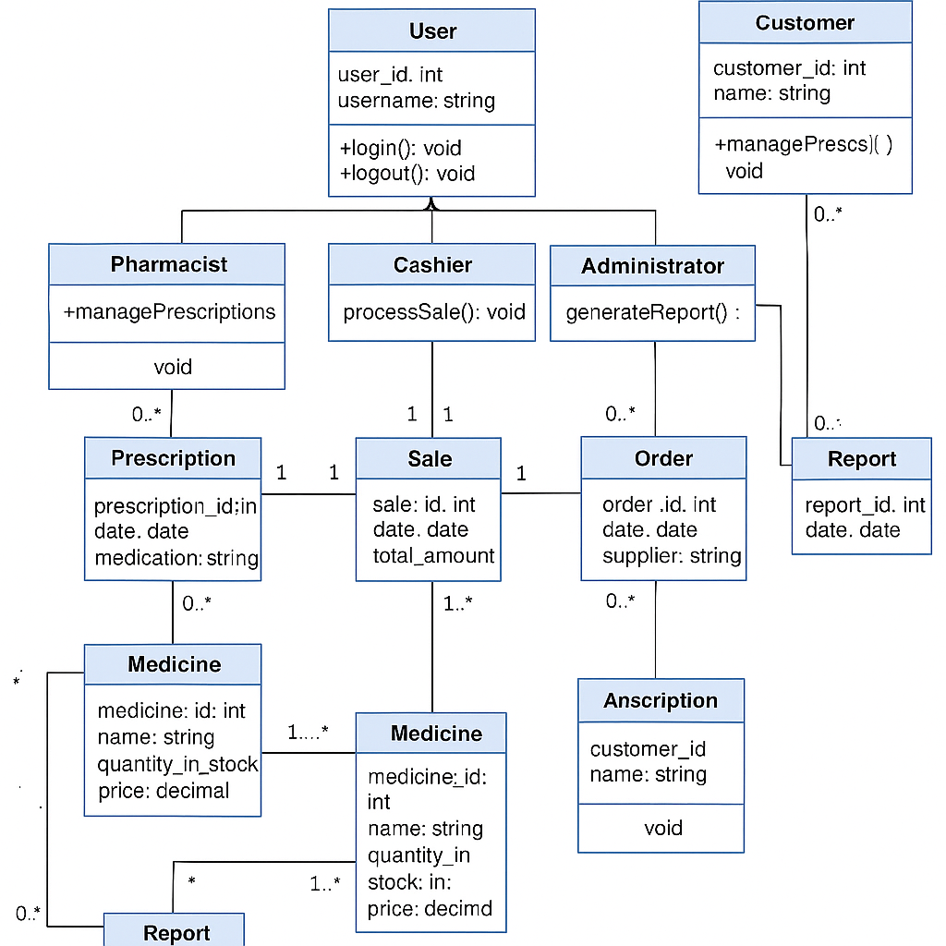

It defines this classes:

1. **User**

* Attributes: userID, name, email, role, password
* Methods: login(), logout()

1. **Customer (inherits User)**

* Attributes: contact, address
* Methods: placeOrder(), viewPrescriptionHistory()

1. **Pharmacist (inherits User)**

* Methods: verifyPrescription(), manageInventory()

1. **Cashier (inherits User)**

* Methods: processPayment(), issueReceipt()

1. **ProcurementStaff (inherits User)**

* Methods: createPurchaseOrder(), manageSuppliers()

f) **Medicine**

* Attributes: medicineID, name, batchNo, expiryDate, quantity, price
* Methods: updateStock(), checkExpiry()

g) **Prescription**

* Attributes: prescriptionID, date, dosage
* Methods: validatePrescription()

h) **Order**

* Attributes: orderID, date, status
* Methods: addMedicine(), calculateTotal()

i) **OrderDetail** (association class between Order and Medicine)

* Attributes: quantity, price

j) **Supplier**

* Attributes: supplierID, name, contact, address
* Methods: supplyMedicine()

k) **Payment**

* Attributes: paymentID, method, amount, date
* Methods: processPayment()

**Entity Relationship Diagram**

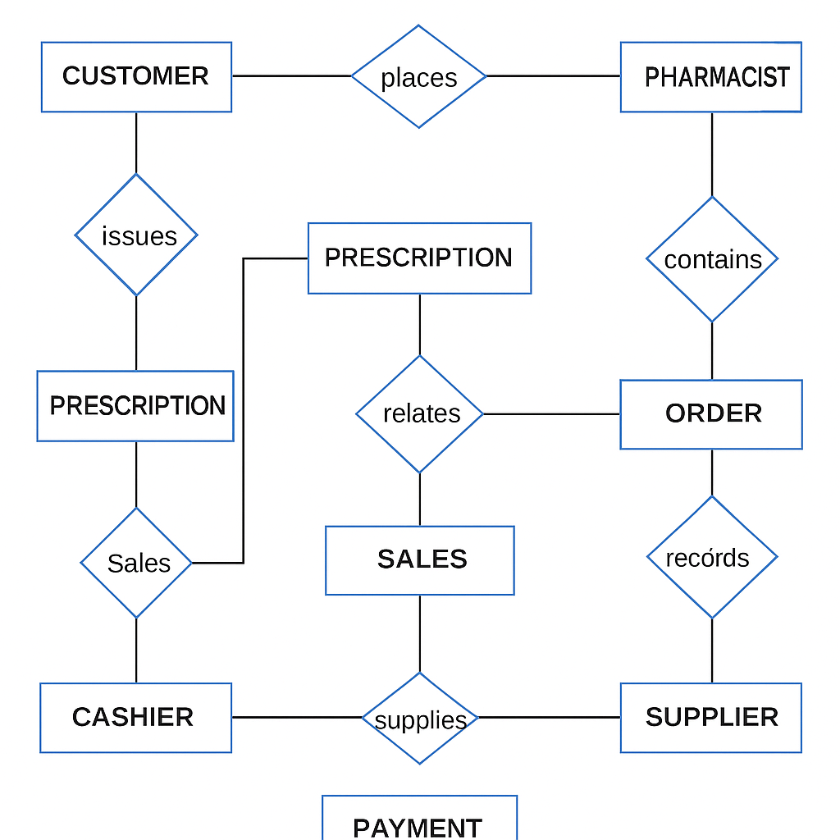

### ****Entities and Relationships****

The Pharmacy Management System is built around several core entities that represent real-world objects and actors involved in daily operations. These entities interact through well-defined relationships that reflect how data is shared and processed within the system.

#### **Entities**

1. **User**
   * Attributes: user_id, name, email, role, password
   * Represents all system users including pharmacists, cashiers, procurement staff, and administrators.
2. **Customer**
   * Attributes: customer_id, name, contact, address
   * Represents individuals who purchase medication or submit prescriptions.
3. **Pharmacist** (Inherits from User)
   * Handles prescription verification and inventory control.
4. **Cashier** (Inherits from User)
   * Processes customer payments and generates receipts.
5. **Procurement Staff** (Inherits from User)
   * Manages suppliers and oversees ordering of stock.
6. **Medicine**
   * Attributes: medicine_id, name, batch_number, expiry_date, quantity, price, supplier_id
   * Represents all medicines in the system, tracked for availability, expiry, and pricing.
7. **Prescription**
   * Attributes: prescription_id, customer_id, medicine_id, dosage, date
   * Captures prescriptions issued to customers and approved by pharmacists.
8. **Order**
   * Attributes: order_id, customer_id, date, status
   * Represents customer orders, whether walk-in or online.
9. **OrderDetail**
   * Attributes: order_id, medicine_id, quantity, price
   * A linking entity between orders and medicines that details what was ordered and in what quantity.
10. **Supplier**
    * Attributes: supplier_id, name, contact, address
    * Represents external pharmaceutical suppliers who provide stock.
11. **Payment**
    * Attributes: payment_id, order_id, method, amount, date
    * Tracks financial transactions for orders, including M-Pesa, cash, and bank transfers.

#### **Relationships**

* **User** has roles (Pharmacist, Cashier, Procurement Staff) that determine access permissions.
* **Customer** can place one or more **Orders**.
* **Order** consists of multiple **OrderDetails**, each linking to a specific **Medicine**.
* **Prescription** is created for a **Customer** and references specific **Medicine** records.
* **Pharmacist** verifies **Prescriptions**.
* **Cashier** processes **Payments** for **Orders**.
* **Procurement Staff** places **Orders** with **Suppliers**, who supply **Medicines**.
* **Each Payment** is associated with exactly one **Order**.

## ****Physical Design****

The Physical Design phase focuses on how the Pharmacy Management System will be implemented, specifying the inputs, outputs, data storage, processing, and system controls.

### ****1. Input Requirements****

The system will use user-friendly forms to capture accurate data:

**Login Form:** Username and password.

**Prescription Entry Form:** Customer information, medicine details, dosage, quantity, and doctor information.

**Inventory Management Form:** Medicine name, batch number, expiry date, quantity, purchase price, and supplier details.

**Sales/POS Form:** Product selection, quantity, price, discounts, payment method (cash, M-Pesa, card).

**Supplier/Procurement Form:** Supplier details, purchase order details, order date, and expected delivery date.

**Online Order Form:** Customer details, selected products, delivery address, and payment method.

### ****2. Output Requirements****

The system will generate the following outputs:

**Receipts:** Printed or digital receipts with itemized purchases, total cost, and payment method

**Reports:**

Daily, weekly, and monthly sales reports.

Inventory stock level reports.

Expiry date alerts and reports.

Supplier performance and delivery reports.

**Dashboards:** Graphical summaries of sales, stock levels, and order statuses for staff and management.

**Notifications:** Low stock alerts, payment confirmations, and online order updates.

### ****3. Storage Requirements****

The system will use a **MySQL database** that stores all information securely:

**Tables:** Users, Customers, Medicines, Prescriptions, Orders, Order_Details, Suppliers, Payments.

**Data Relationships:** Established using primary keys (e.g., MedicineID, OrderID) and foreign keys for data integrity.

**Indexes:** Applied to frequently queried fields (e.g., MedicineName, CustomerName) to improve performance.

**Data Retention:** Historical data will be archived periodically to maintain database efficiency

### ****4. Processing Requirements****

The system will process data as follows:

**Stock Management:** Deduct quantities automatically after each sale and update stock after deliveries.

**Prescription Verification:** Validate prescription details before dispensing medicines.

**Sales Calculations:** Automatically compute totals, discounts, and taxes at the POS.

**Expiry Alerts:** Check expiry dates during inventory updates and generate notifications

for soon-to-expire products.

**Reports & Dashboards:** Aggregate and display real-time data for decision-making.

### ****5. System Controls & Backup****

To ensure data security and reliability, the system will include:

**User Access Control:** Secure login with encrypted passwords and role-based permissions (Admin, Pharmacist, Cashier, Procurement Staff).

**Data Validation:** All inputs validated both on the client-side (frontend) and server-side (backend) to prevent errors.

**Error Handling:** Friendly error messages for users and error logging for administrators.

**Backups:** Automatic daily database backups with a restore option in case of data loss.

**Data Security:** Sensitive data (passwords, customer information) encrypted during storage and transmission.

**Deployment diagram**

A deployment diagram illustrates how the Pharmacy Management System’s software components are distributed across hardware devices, such as staff computers, servers, and customer devices, and how they interact with each other.

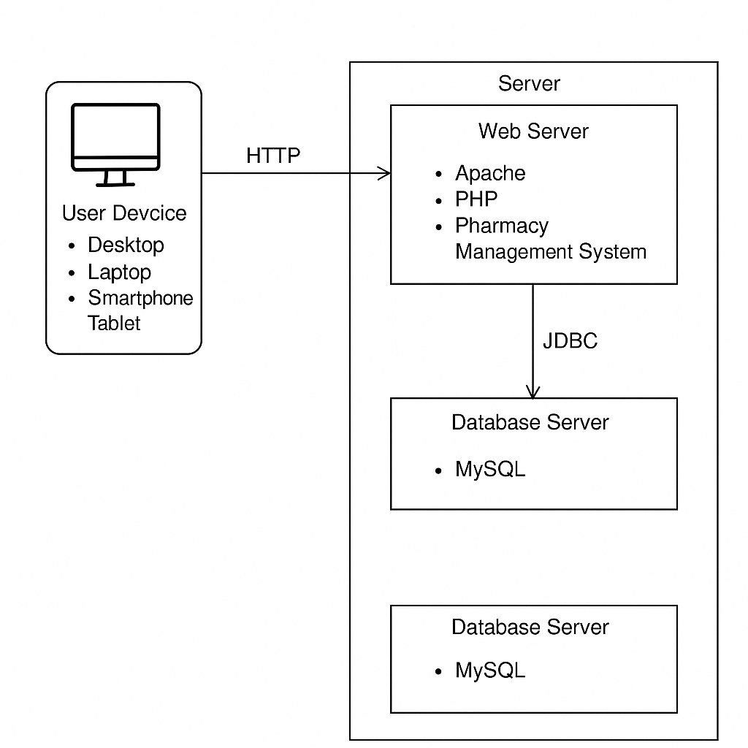

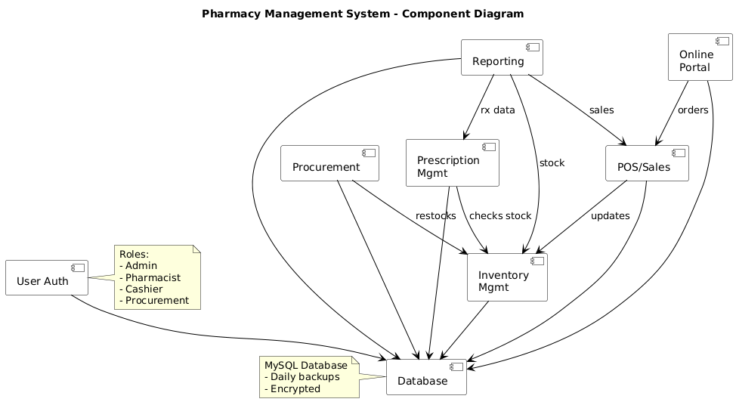

The component diagram illustrates how the Pharmacy Management System is organized into distinct functional modules and how they interact with each other. It shows the **User Authentication** module enforcing role-based access control for Admin, Pharmacist, Cashier, and Procurement staff. The **Procurement** module handles supplier orders and restocking, while the **Prescription Management** module manages prescription entry and verification. **Inventory Management** tracks real-time stock levels, receiving updates from Procurement and **POS/Sales**, which processes both in-store and online transactions. The **Online Portal** allows customers to place orders that are directly linked to the POS/Sales module. The **Reporting** module compiles data from sales and prescriptions to generate analytical reports for management. All components interact with the centralized **MySQL database**, which is encrypted and backed up daily for security and reliability. This modular structure ensures efficient data flow, accurate real-time updates, and improved scalability of the system.

## ****Interface Design****

The Interface Design focuses on how users will interact with the Pharmacy Management System (Ultracare PMS). It defines the appearance, layout, and navigation of the system’s screens to ensure usability, efficiency, and accuracy.

### ****1. Purpose of the Interface Design****

The main objective of the interface design is to provide users (pharmacy staff, customers, and suppliers) with an intuitive and user-friendly environment. Interfaces are designed to:

Minimize input errors through clear prompts and validations.

Enable quick access to core functions such as inventory management, sales, and reporting.

Ensure consistent layout, colors, and font styles across all modules.

Support both desktop and mobile devices for flexibility.

### ****2. Key Interfaces****

The system will have the following major interfaces:

**Login Page**

Fields: Username and Password.

Buttons: Login, Reset Password.

Features: Displays error messages if invalid credentials are entered.

**Dashboard**

Displays a summary of stock levels, sales performance, pending orders, and alerts.

Provides quick navigation links to other modules (POS, Inventory, Suppliers, Reports).

**POS (Point-of-Sale) Screen**

Allows staff to process customer sales and payments.

Fields: Customer details, selected products, quantity, payment method (cash, M-Pesa, card).

Generates and prints receipts after a successful transaction.

**Inventory Management Screen**

Used by staff to add, edit, or delete medicine records.

Displays stock levels, batch numbers, and expiry dates.

Shows automatic alerts for low stock or expired products.

**Suppliers & Procurement Screen**

Manages supplier information and purchase orders.

Tracks pending deliveries and updates stock levels upon receipt.

**Reports & Analytics Screen**

Generates detailed reports on sales, inventory, and suppliers.

Allows export to PDF or Excel for further analysis.

**Online Orders Screen (Customer Interface)**

Displays the product catalog with a search feature.

Allows customers to place orders, provide delivery details, and make online payments.

### ****3. Design Considerations****

**Consistency:** Each screen will use the same color scheme, typography, and button styles to provide a unified experience.

**Navigation:** A sidebar or top navigation bar will be included for quick access to different modules.

**Validation & Feedback:** Forms will have field validation (e.g., required fields, correct data formats). Users will receive confirmation or error messages after actions.

**Responsive Design:** Interfaces will be optimized for desktop and mobile devices.

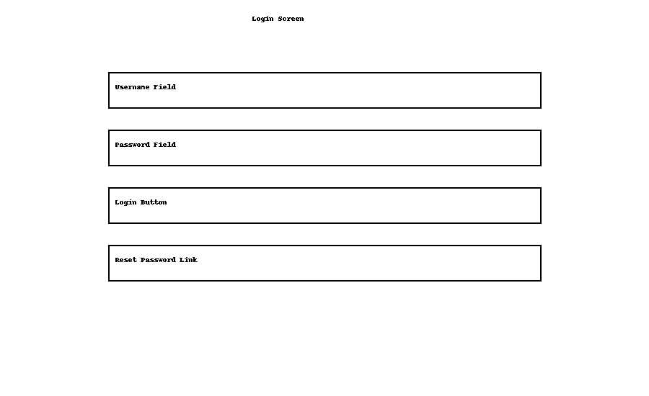

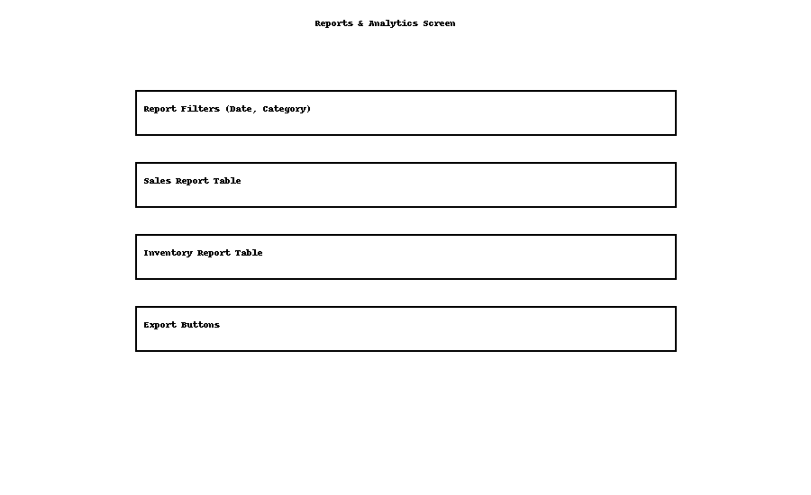

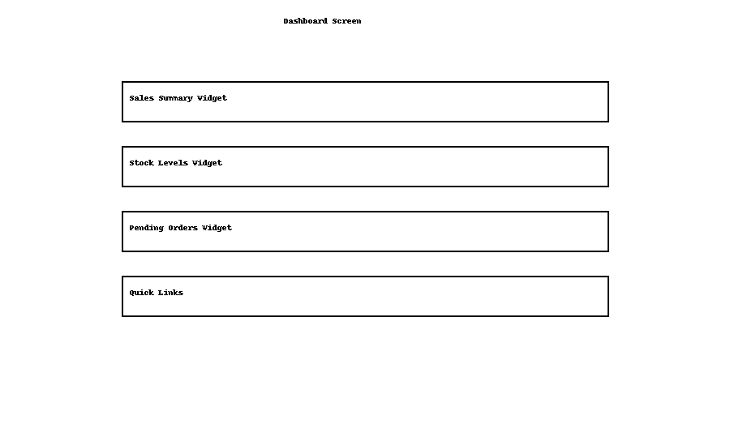

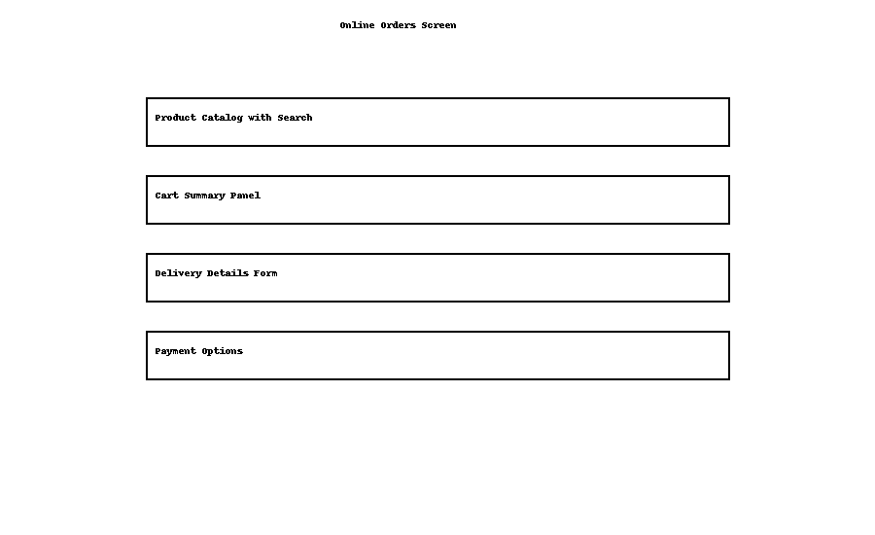

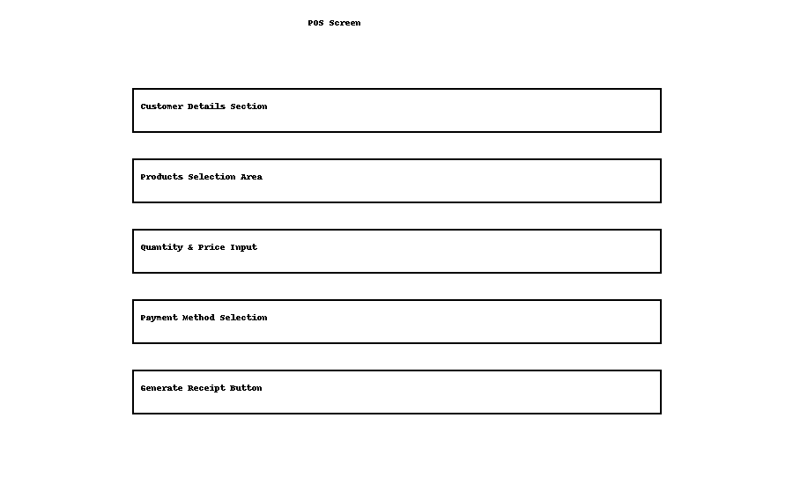

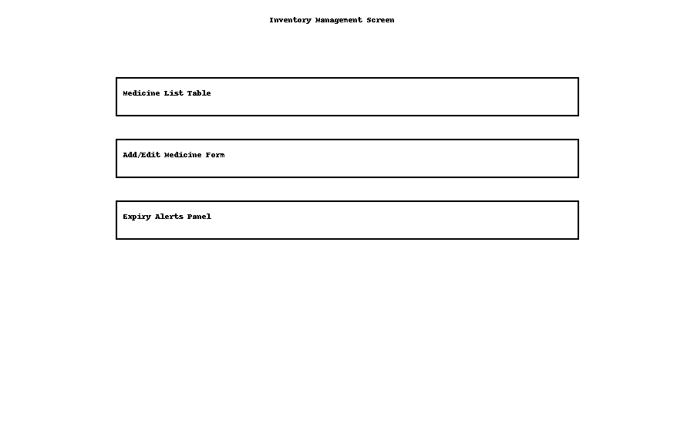

**DATABASE DESIGN**

The database design defines how data is structured and organized to ensure secure storage, efficient access, and consistent management. For the Pharmacy Management System, a relational database model was implemented because of its reliability, support for structured queries (SQL), and ability to enforce data relationships effectively.

The database is built around key entities such as users, customers, medicines, prescriptions, orders, suppliers, and payments. Each entity is represented as a table with specific fields designed to handle the data it manages.

To maintain data integrity and reduce redundancy, the tables were normalized and designed with primary and foreign key constraints. Relationships between tables (e.g., one-to-many or many-to-one) were established to support efficient querying, accurate reporting, and secure access control across the system.

The Database Design defines how data will be stored, related, and retrieved in the Pharmacy Management System. It ensures data integrity, avoids redundancy, and supports efficient queries.

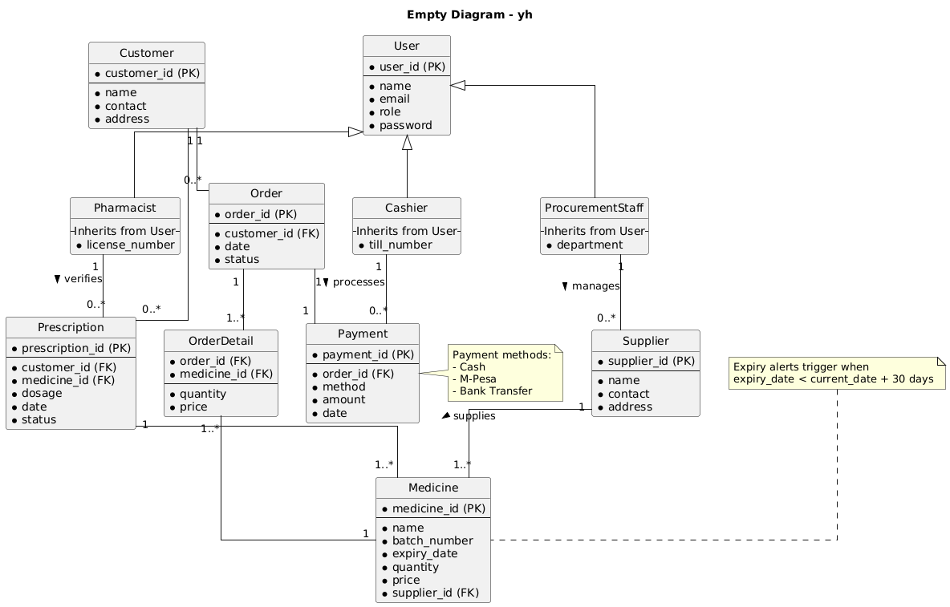

The Entity Relationship Diagram (ERD) illustrates the key entities and relationships that form the foundation of the Pharmacy Management System’s database.

**Entity Relationships**

* A **User** (Admin, Pharmacist, Cashier, Procurement) can perform multiple actions such as managing inventory, processing sales, or verifying prescriptions.
* A **Customer** can place multiple **Orders**, but each order belongs to a single customer.
* Each **Order** can have multiple **OrderDetails**, and each order detail refers to a specific **Medicine**.
* A **Supplier** can supply multiple **Medicines**, but each medicine is linked to one supplier.
* A **Prescription** belongs to one **Customer** and can include multiple **Medicines**.
* Each **Payment** is linked to a single **Order**, but an order must have at least one payment record.
* **Medicines** are updated in real-time through sales, prescriptions, and procurement processes, ensuring accurate stock levels.

**Schema diagram**

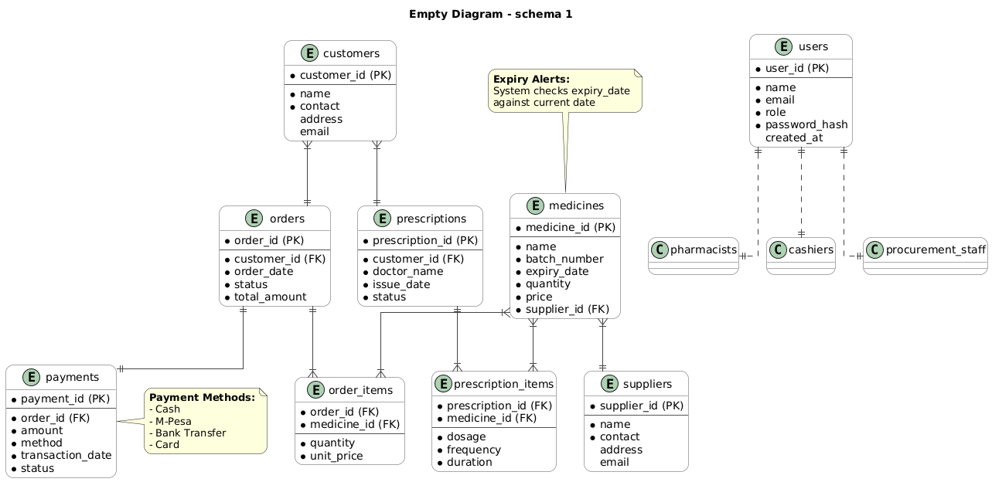

The Pharmacy Management System schema is designed to efficiently manage customers, prescriptions, medicines, suppliers, orders, payments, and user roles. It captures detailed customer and prescription information, links prescriptions and orders to specific medicines, and maintains inventory with supplier details. A built-in expiry alert system ensures medicines are safe for use by checking expiry dates. The system supports multiple payment methods (Cash, M-Pesa, Bank Transfer, Card) and logs transactions for each order. Role-based access control is implemented to manage different user types, including pharmacists, cashiers, and procurement staff. Overall, the schema supports streamlined pharmacy operations, inventory control, secure user management, and reliable transaction tracking.

# **CHAPTER FOUR**

# **SYSTEM IMPLEMENTATION**

System implementation involves creating and testing the Pharmacy Management System based on the design and specifications established in the analysis and design phase. The goal was to build a functional solution that automates Ultracare Pharmacy’s operations, ensures accurate record-keeping, and provides an online pharmacy platform. The main activities in this phase included **code generation, system integration, testing, and documentation**.

## ****a) Code Generation****

### Tools and Resources

* **Hardware Resources**
  + Laptop: Intel Core i5 processor, 4GB RAM, 256GB storage
  + Flash Drive (16GB) for backups
  + Internet access for updates and research
* **Software Resources**
  + IDE: Visual Studio Code
  + Local Server: XAMPP (Apache, MySQL, PHP, Perl)
  + Database: MySQL
  + Programming Languages: PHP (backend), HTML, CSS, JavaScript (frontend)
  + Version Control: Git for source code management

### Implementation

Using the above tools, the following system modules were coded:

1. **User & Role Management** – secure login, registration, and role-based access (Admin, Pharmacist, Cashier, Procurement, Customer).
2. **Prescription Management** – digital entry, verification, and storage of prescriptions.
3. **Inventory Management** – stock tracking, expiry alerts, and automatic restock notifications.
4. **Sales & POS Module** – customer billing, receipt generation, and payment integration (Cash, M-Pesa, Bank transfer).
5. **Supplier & Procurement Module** – purchase orders, supplier management, and delivery updates.
6. **Bulk Order Management** – for clinics and institutions.
7. **Online Pharmacy Platform** – customers browse, upload prescriptions, place orders, and make payments.
8. **Reports & Analytics** – automated generation of sales, stock, and supplier reports.
9. **AI Chatbot** – a smart support assistant integrated into the system to improve customer and staff interaction.

### ****AI Chatbot Implementation****

An **AI-powered chatbot** was developed to enhance the Pharmacy Management System by providing automated responses and support.

* **Tools & Technologies**
  + PHP & JavaScript for integration
  + NLP techniques (rule-based interpretation of text queries)
  + Database connectivity for real-time responses
  + Web interface embedded on the system frontend
* **Key Features**
  + Responds to greetings and customer inquiries (pharmacy hours, available medicines).
  + Assists staff with quick queries such as “Check stock levels” or “Generate sales report.”
  + Provides customers with automated information about prescriptions, orders, and payments.
  + Reduces repetitive questions, saving staff time.

## ****b) Software System Integration****

System integration involved combining the independently developed modules into one centralized system. The **frontend interfaces** (HTML, CSS, JavaScript) were connected to the **backend logic** (PHP) and the **MySQL database**.

Key integrations included:

* POS linked with **Inventory** → auto-updates stock after every sale.
* Procurement linked with **Suppliers and Inventory** → stock updates upon delivery.
* Prescription verification integrated with **Sales & Inventory** → ensuring accuracy.
* Online platform integrated with **Orders, Payments, and Customer records**.
* Reports module drawing data from all subsystems.
* AI Chatbot connected with the **database and modules** → able to retrieve and display stock, sales, or pharmacy information in real time.

The integrated system was then deployed on a **local XAMPP server** for testing.

## ****c) Software System Testing****

Testing was conducted to ensure that the Pharmacy Management System functioned according to requirements.

### Types of Testing Performed:

1. **Unit Testing** – each module tested independently (e.g., login, chatbot responses, prescription entry).
2. **Integration Testing** – ensured that combined modules worked together correctly (e.g., chatbot correctly fetched data from inventory).
3. **System Testing** – tested the entire workflow including sales, prescriptions, procurement, reporting, and chatbot interactions.
4. **User Acceptance Testing (UAT)** – Ultracare staff tested the system to confirm usability, accuracy, and chatbot usefulness.

### Errors Identified and Fixed:

* **Login validation errors** – improved error messages for invalid credentials.
* **Inventory mismatch** – fixed issue where expired drugs were not excluded from sales.
* **Payment duplication** – prevented duplicate transactions by adding transaction checks.
* **Chatbot misinterpretation** – refined rule-based responses to better understand common queries.

The final system passed all critical tests, achieving the set objectives for reliability, accuracy, usability, and intelligent user interaction.

# **CHAPTER FIVE**

# **CONCLUSION AND RECOMMENDATIONS**

## ****Conclusion****

The Pharmacy Management System developed for Ultracare Pharmacy successfully automates operations such as prescription handling, inventory management, sales processing, procurement, reporting, and customer engagement. It eliminates inefficiencies of the manual system through **real-time updates, expiry alerts, digital receipts, and online ordering**.

The addition of an **AI-powered chatbot** further enhanced the system by improving user interaction. Customers and staff can query the chatbot for quick answers about medicine availability, pharmacy details, or reports, reducing delays and repetitive workload.

Overall, the system improves customer service, enhances operational accuracy, ensures compliance with prescription handling, and positions Ultracare Pharmacy for growth and digital transformation.

## ****Recommendations****

1. **Deployment to Live Server** – move the system from local (XAMPP) to a secure cloud server.
2. **Staff Training** – short training sessions for pharmacists, cashiers, and procurement staff to improve adoption.
3. **System Maintenance & Updates** – regular database backups and security updates.
4. **Scalability** – extend the system to support multiple branches.
5. **Mobile App Development** – create a mobile version for online customers.
6. **AI Chatbot Enhancements**
   * Upgrade from rule-based to machine learning for better natural language understanding.
   * Add multilingual support (e.g., English & Swahili).
   * Integrate voice-based interaction for accessibility.
7. **Advanced Analytics** – incorporate business intelligence tools for deeper sales and customer insights.

INTRODUC